**4. Project Design Phase**

**4.1 Problem – Solution Fit**

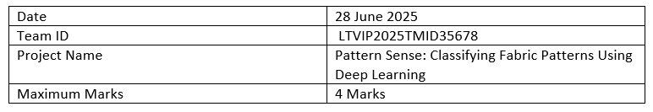

**Problem – Solution Fit:**

The Problem–Solution Fit ensures that the solution designed truly addresses the core needs of the target users. In the case of **Pattern Sense**, the solution was developed to solve two major real-world problems: inefficient manual pattern classification in textile manufacturing, and the lack of searchable pattern-based filters in online clothing platforms. Through deep learning, our system automates pattern recognition, saving time, reducing errors, and improving end-user satisfaction.

**Purpose:**

The purpose of the Problem–Solution Fit in the *Pattern Sense* project is to ensure that the solution we designed truly addresses the core pain points and unmet needs of our target users — textile inspectors and e-commerce managers. This phase helps us verify that our AI-driven fabric pattern classifier is not just innovative, but also practical and impactful.

By deeply understanding user behaviors, limitations, and frustrations, we identified a strong match between the problem (manual, slow, and error-prone pattern identification) and our solution (an automated CNN-based classifier integrated with a web app interface).

The fit between the problem and the solution ensures:

* Enhanced productivity and accuracy in textile quality control
* A better user experience for shoppers using pattern-based filtering
* Reduced cognitive load and fatigue for industry professionals
* Increased adoption potential due to solving a real and urgent challenge

Ultimately, this step lays the foundation for building a meaningful, user-centered product that not only works — but works where it matters most.

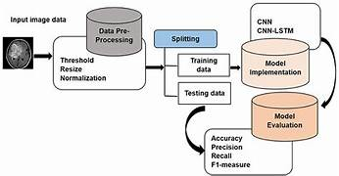

**1. Customer Segment(s)**

* Textile quality control professionals
* E-commerce platform managers

**2. Customer Constraints**

* Manual classification is slow and error-prone
* Lack of structured, labeled pattern data for clothing images

**3. Available Solutions**

* Manual inspection and spreadsheet-based logging
* Visual similarity search (rare, unreliable)

**4. Jobs to Be Done / Problems**

* Need to classify fabric patterns quickly and accurately
* Improve customer shopping experience with pattern-based filtering

**5. Problem Root Cause**

* No automation in pattern detection or tagging
* Lack of deep learning integration into textile workflows

**6. Behavior**

* Inspectors rely on visual comparison and memory
* Customers browse without specific pattern filters

**7. Triggers**

* Delays and fatigue during quality checks
* Frustration in online clothing search

**8. Your Solution**

* CNN-based fabric pattern classifier
* Flask web app for interactive image uploads and predictions

**9. Emotions: Before / After**

* *Before:* Frustrated, tired, confused
* *After:* Confident, quick, satisfied

**10. Channels of Behavior**

* Deployed as a web app with an image upload interface
* Possible API integration for e-commerce backends